Robots

- Definitions +.25
- A robot is an automatically guided machine which is able to do tasks on its own.
- Any machine or mechanical device that operates automatically with human like
skill.
- A person who acts and responds in a mechanical, routine manner, usually subject to another’s will; automaton

Why will robots never take over the world? +

Intelligence is much more than the raw ability to make calculations – computers can already beat us at chess. Intelligence requires the ability to learn, to understand and to interpret. Artificial intelligence is already highly sophisticated, yet its improvement requires research and research is a slow process. Malcolm wittily followed this argument with a story about a robotocist and a physicist. The robotocist dared the physicist that she’d be able to create a robot the physicist would be unable to destroy. A year later the robotocist showed the physicist a small furry robot, which looked far from invincible, handing her a hammer to smash it with. But when the physicist lifted the hammer, the robot promptly flipped onto its back and squeaked piteously. Distressed, the physicist was unable to destroy it. The robot was simply programmed to react in such a manner. It did not feel actual fear. However, the human associated the robots behavior with hard-wired instinct that would make it very difficult to hurt the robot. This analogy cleverly shows that robots would simply be an imitation of humans and not actual humans possessing human
desires. Therefore, even though humans naturally want to lord over everything, why should a robot?

+.25
The key difference is that humans have been crafted by 3.7 billion years of evolution. The process of evolution is a simple concept with an incredible level of complexity behind it that computers have not gone through. So where would they gain the desire to be, like humans, voraciously self-replicating, lust after power, out-compete others for resources and, above all else, survive? It might be possible to program all these qualities into a robot, but why would we want to? Furthermore, great leaps in research would be required to reach the level of technology and software development needed to instil such attributes into a robot. +.75

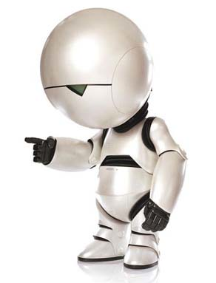
The Blainbot 3000

